USER INTERFACE AND DESIGN
EXPERIMENT – 7
Name : SHERIN KATHERINA D Roll No : 240701495

Experiment with different layouts and color schemes for an app. Collect user feedback on aesthetics and usability using GIMP(GNU Image Manipulation Program (GIMP)
Prototype – E-Commerce App (Light Theme)
Theme: Light with soft blue accents
Layout: Card-based scrolling layout
Features: Search bar, product cards, offers banner, cart option
Design Focus: Clean shopping experience with clear product visibility
Pros:
• Attractive and modern UI
• Easy to navigate
• Clear product display
• Good color contrast
Cons:
• Can feel slightly crowded if too many products
• Requires proper spacing for better readability
Feedback Collection:
Feedback was collected using Google Forms.
Questions Asked:
• How is the overall design?
• Is the website easy to use?
• Are colors appealing?
• Any suggestions for improvement?
Analysis of Feedback:
• Most users liked the clean layout
• Users found navigation easy
• Some users suggested improving spacing
• Few suggested bigger buttons
Improvements Made:
• Increased spacing between product cards
• Improved button size and visibility
• Enhanced color contrast
Google form feedback responses :
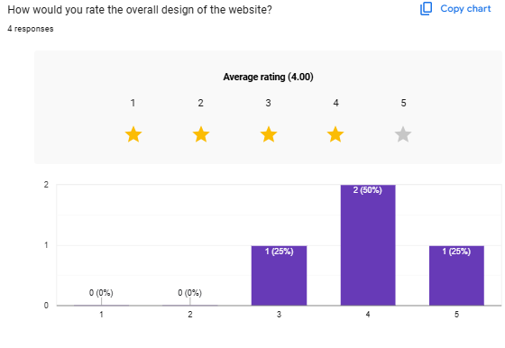
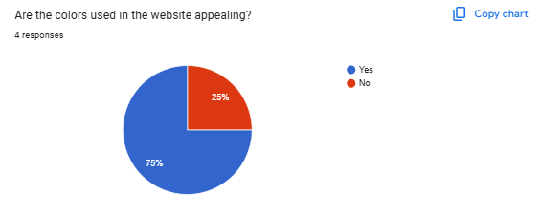
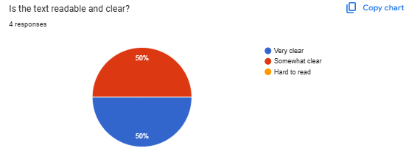
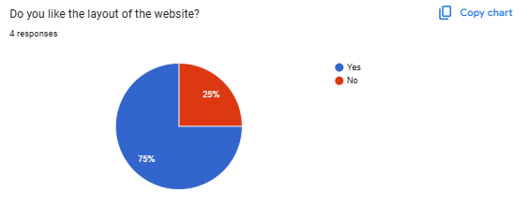
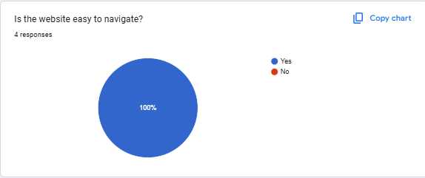
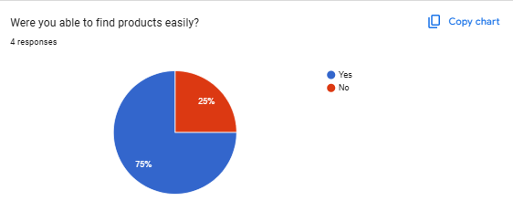
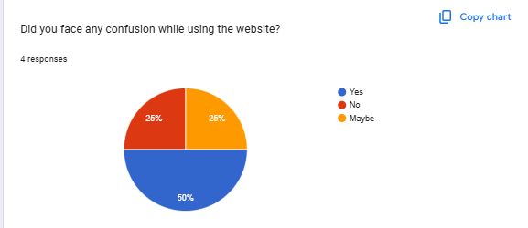
Prototype link after refining the design :
https://www.figma.com/proto/KO6m2ft9rRyUuICZXTd4QQ/Untitled?node-id=2-2&p=f&t=mfki6IvgLYgGDL5v-0&scaling=scale-down&content-scaling=fixed&page-id=0%3A1&starting-point-node-id=2%3A2&show-proto-sidebar=1
Result:
The refined design improved usability, readability, and user satisfaction.

